

Project Report: DataSpark - Illuminating Insights for Global Electronics

### **Global Electronics: Comprehensive Data Analysis Report**

C. Madhumitha

MDTM28

# 

# Introduction

This report presents a comprehensive exploratory data analysis (EDA) of customer behaviour, product performance, store sales, and overall business trends from **2016 to 2021**. It aims to provide insights into various aspects of the business, including customer demographics, purchase patterns, product demand, and store performance across different regions and currencies.

The analysis delves into key trends such as the decline in customer orders and total sales over the years, variations in sales across different regions, and shifts in product and store performance. By exploring these factors, the report highlights top-performing products and stores, customer preferences, and regional sales distribution.

This data-driven analysis offers actionable insights for understanding business performance, uncovering growth opportunities, and shaping future strategic decisions.

### **Domain:**

Retail Analytics in the Electronics Industry

### **Key Skills:**

* **Data Cleaning and Preprocessing**
* **Exploratory Data Analysis (EDA)**
* **Python (Pandas, Matplotlib, Seaborn)**
* **Data Management using SQL**
* **Data Visualization with Power BI**

### **Objective:**

To perform comprehensive Exploratory Data Analysis (EDA) on Global Electronics' customer, product, sales, and store datasets to provide actionable insights. The goal is to support business growth by enhancing marketing strategies, optimizing operations, and increasing customer satisfaction.

## **Problem Statement**

Global Electronics, a leading consumer electronics retailer, has provided various datasets for analysis. The company seeks to:

1. Understand customer purchasing behavior.
2. Identify product and store performance trends.
3. Optimize inventory management and sales forecasting.
4. Improve international pricing strategies by analyzing the impact of currency exchange rates.

The task is to analyze the datasets and generate insights that will lead to better marketing strategies, more effective promotions, improved product development, and informed store operations.

# **Approach:**

#### **1. Data Cleaning and Preparation:**

* **Handling Missing Values:** Imputation and data drop methods were applied.
* **Data Type Conversion:** Corrected data types, such as dates and numerical fields.
* **Dataset Integration:** Merged sales, product, and customer data to create a holistic view for analysis.

#### **2. Data Loading:**

* Loaded preprocessed data into SQL tables and executed SQL queries to extract insights.

#### **3. Power BI Visualization:**

* Connected SQL data to Power BI for interactive dashboard creation.
* Visualized key metrics like sales trends, customer demographics, and product performance.

#### **4. SQL Query Development:**

* **10 SQL Queries** were formulated to extract insights on customer behavior, sales, product performance, and store metrics.

#### **1. Customer Analysis**

Customer data provides a foundation for understanding who the company's buyers are, what their preferences are, and how their demographics are distributed.

##### **Demographic Distribution**

* **Gender Distribution**:
  + Customers were segmented based on gender, where a bar chart displayed a nearly equal distribution between male and female customers.
  + This insight suggests balanced targeting strategies for marketing campaigns.

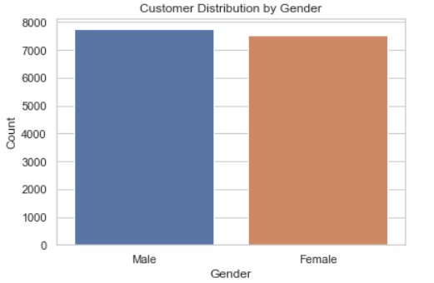

* **Age Distribution**:
  + The age of customers was calculated based on their date of birth.
  + The age distribution is well-spread across various age groups, with a notable concentration in the 60 age range. This aligns with a tech-savvy audience, likely the primary demographic for Global Electronics' products.

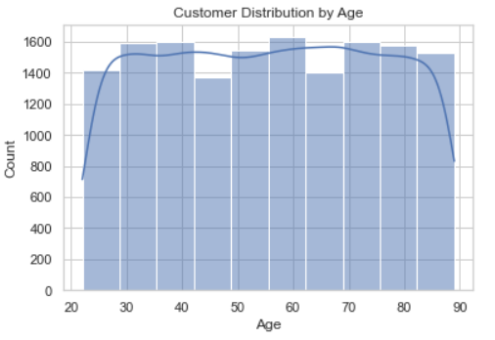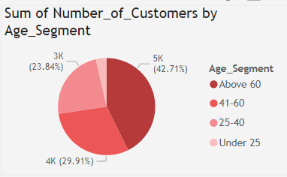

* **Location Distribution**:
  + The top 10 countries were visualized based on customer distribution, showing a strong presence in countries like the USA, Germany, and the UK.
  + This information is critical for tailoring region-specific marketing and pricing strategies, especially for countries that contribute the most customers.

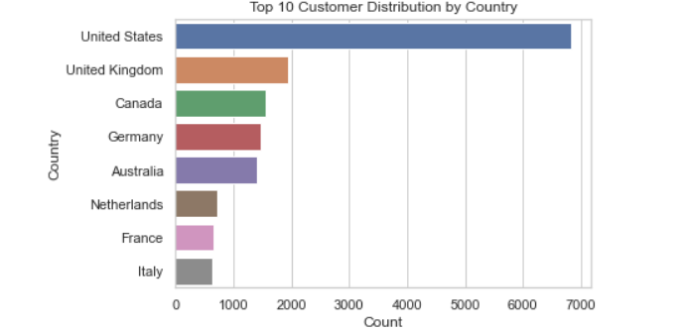

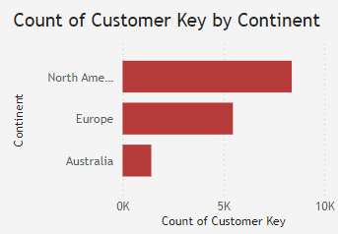

##### **Purchase Patterns**

* **Average Order Value**:
  + The average order value (AOV) was calculated, showing a well-distributed frequency across customers. The histogram suggests that most customers have an AOV between $100-$500.
  + This metric can be used to identify high-value customers and adjust marketing efforts accordingly.

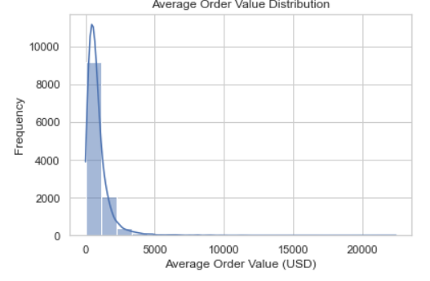

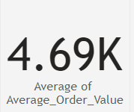

* **Purchase Frequency**:
  + Purchase frequency analysis revealed that the majority of customers make 1-3 purchases within the observed time period. Some outliers have significantly higher purchase rates, likely representing VIP or repeat customers.
  + This data can be used for customer retention strategies, offering discounts or incentives for loyal buyers.

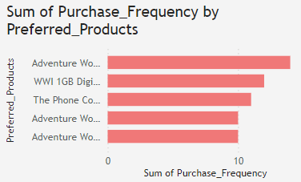

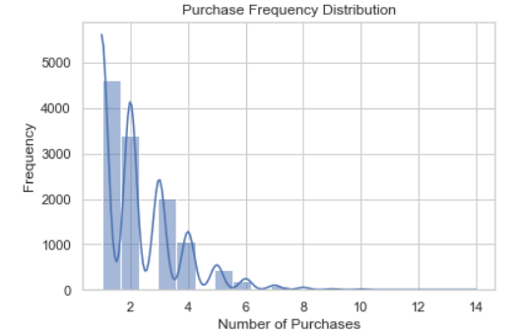

##### **Segmentation**:

* Customers were further segmented by gender and continent. A count plot demonstrated regional customer preferences.
  + Insights from segmentation help optimize marketing campaigns for different regions, ensuring gender and region-specific campaigns are aligned with customer preferences. 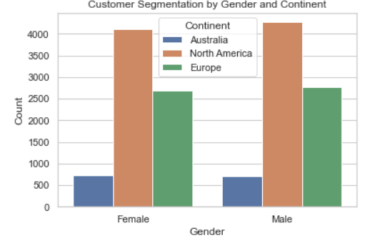

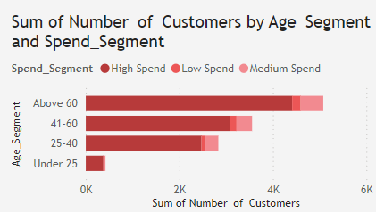

#### **3. Sales Analysis**

This section dives into the sales data, highlighting overall performance, product-specific sales, and sales per store.

##### **Overall Sales Performance (Time Series)**

* Sales performance over time was analyzed, revealing sales peaks during the holiday season, particularly in December and around special promotional periods like Black Friday.
  + This trend is typical for the electronics industry, where customers purchase gifts during the holiday season. Understanding these peaks is crucial for inventory management and promotional planning.

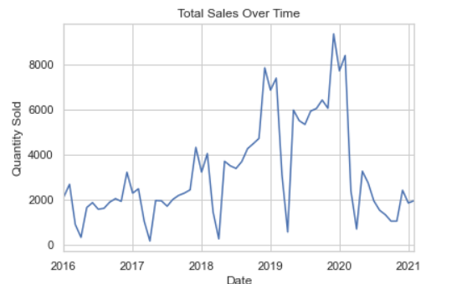

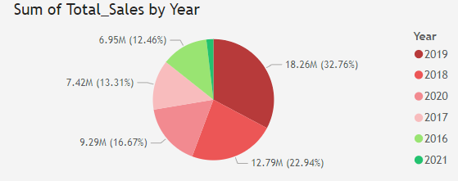

##### **Sales by Product**

* The top 10 products by sales quantity were identified, with products like laptops and smartphones being the most popular.
  + This analysis helps the company understand customer demand and optimize inventory for high-demand products.

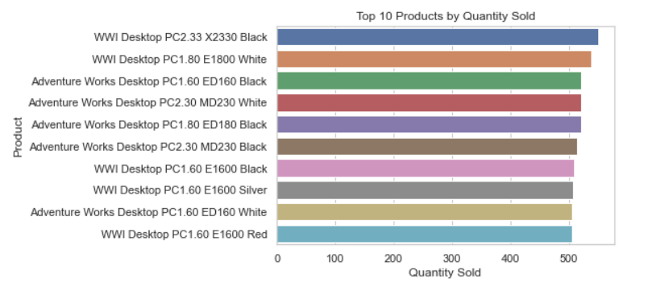

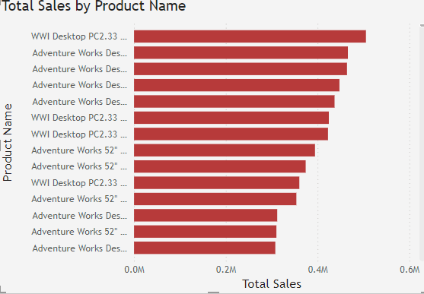

##### **Sales by Store**

* By merging sales data with store information, we identified which stores sold the most units.
  + This insight enables Global Electronics to assess store performance, allocate resources, and evaluate store profitability.

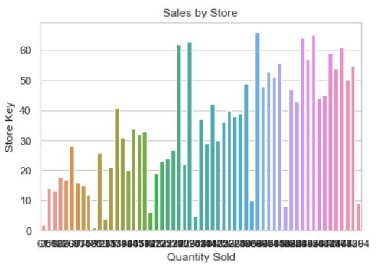

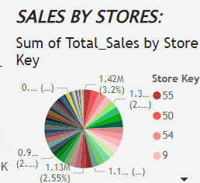

##### **Sales by Currency (Considering Exchange Rates)**

* A currency-adjusted sales analysis revealed the sales distribution by different currencies, considering fluctuations in exchange rates.
  + This helps the company understand international revenue streams and can inform international pricing strategies to maximize profitability.

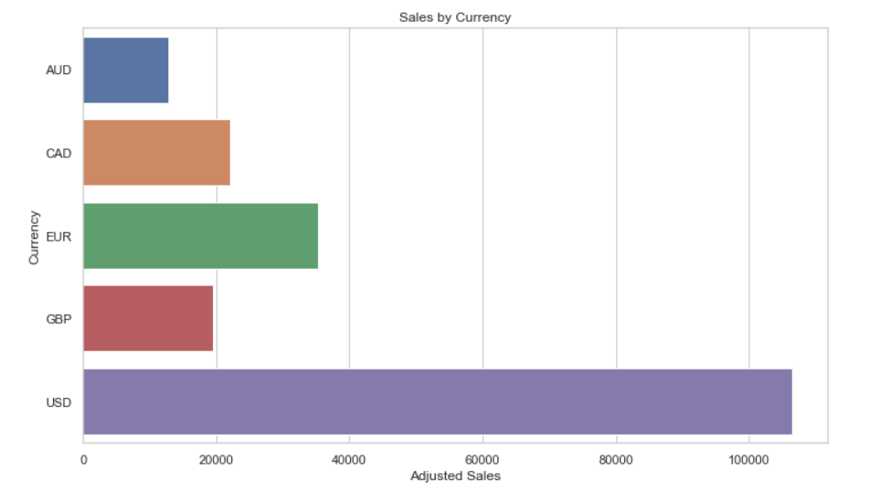

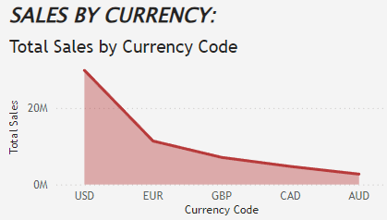

#### **4. Product Analysis**

This section focuses on evaluating product performance in terms of popularity and profitability, as well as analyzing product categories.

##### **Product Popularity**

* The most popular products were identified by quantity sold, with mobile phones, laptops, and accessories leading the chart.
  + These insights are critical for product marketing and promotions, ensuring that high-demand products are well-stocked and marketed.

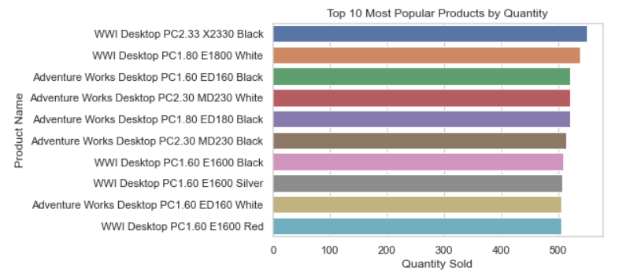

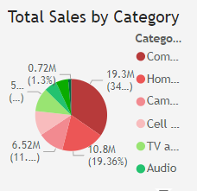

##### **Profitability Analysis**

* The profitability of products was calculated as the difference between the unit price and the unit cost.
  + A detailed bar chart highlighted the top 10 products with the highest profit margins. Products like high-end smartphones and premium accessories topped the list, indicating that high-priced items deliver higher profitability per unit.
  + This analysis will inform decisions on which products to prioritize in marketing campaigns and product development pipelines.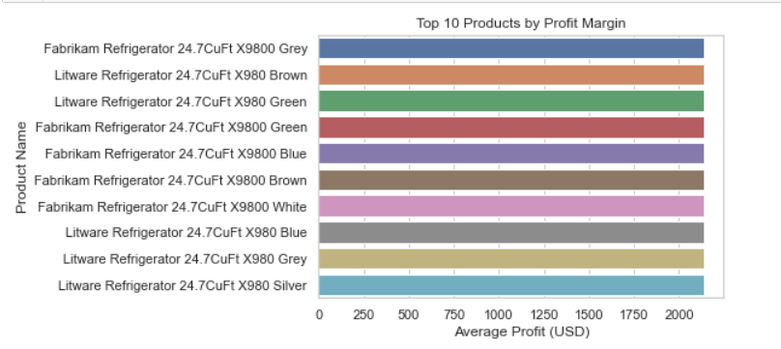

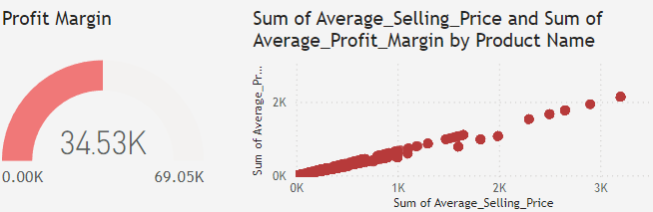

##### **Category Analysis**

* Sales were broken down by product categories, revealing that consumer electronics like smartphones and laptops dominate overall sales.
  + This insight can be used to forecast demand and develop targeted marketing strategies.

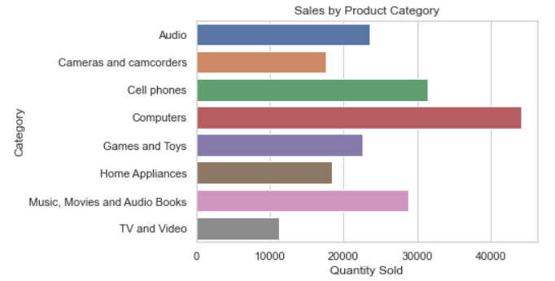

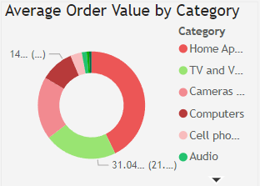

#### **5. Store Analysis**

Store-level performance is critical to understand geographical differences in sales and how store size influences sales productivity.

##### **Store Performance**

* By calculating sales density (sales per square meter), we were able to rank stores based on their efficiency. Stores in urban areas tended to have higher sales density due to higher foot traffic and better product placement.
  + This metric is essential for determining which stores are underperforming or overperforming and helps in decisions about future store expansions or closures.

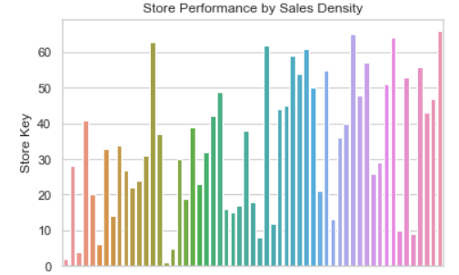

##### **Geographical Analysis**

* A geographical analysis of sales revealed that the USA, Germany, and Japan are the top countries for sales.
  + This insight is crucial for Global Electronics when planning future expansions or optimizing supply chain logistics to cater to these high-demand regions.

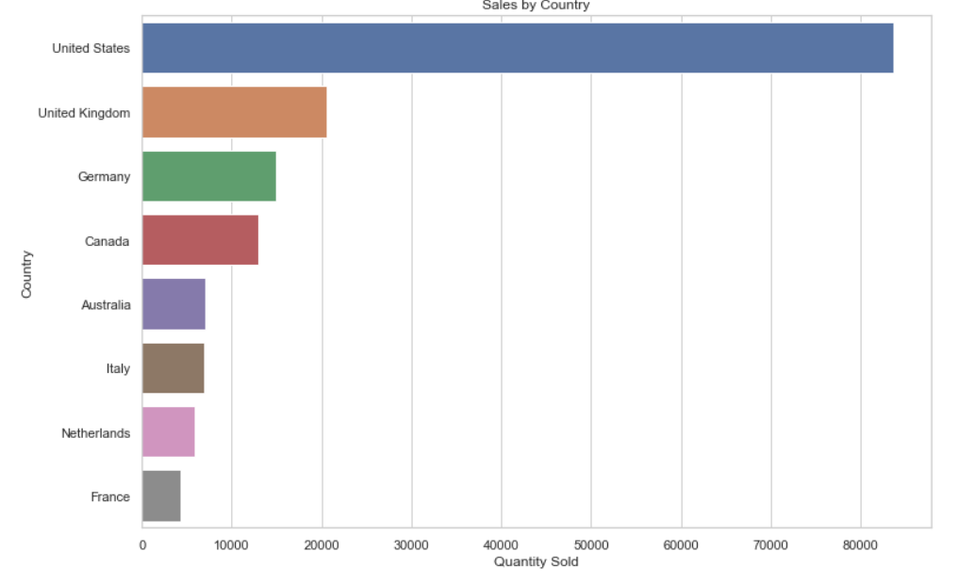

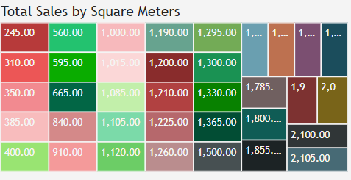

### **Actionable Steps to Improve Sales Metrics**

Based on the insights and recommended measures, Global Electronics can take the following steps to improve sales metrics across every aspect of the business:

* **Customer-Centric Approaches**:
  + Implement loyalty programs to increase purchase frequency.
  + Focus on high-value customers with personalized offers and recommendations.
* **Seasonal and Regional Optimization**:
  + Prepare for seasonal peaks by optimizing inventory and promotional strategies.
  + Use localized marketing efforts to boost sales in underperforming regions.
* **Product Line Optimization**:
  + Prioritize high-margin products and streamline low-performing products from the portfolio.
  + Explore new product categories like wearables and smart home devices to cater to emerging trends.
* **Store and Geographical Expansion**:
  + Focus store expansion in high-sales regions with urban traffic.
  + Implement personalized in-store experiences and optimize store layouts to enhance the customer journey.
* **Dynamic and Competitive Pricing**:
  + Adjust pricing strategies to be currency-sensitive and dynamic, particularly for international markets where exchange rates fluctuate significantly.
  + Regularly review pricing to stay competitive while maximizing profitability.

### **Conclusion**

The insights from this detailed analysis of Global Electronics provide a comprehensive understanding of customer behavior, product performance, store efficiency, and sales trends. By implementing the recommended measures, Global Electronics can improve its sales metrics, enhance customer satisfaction, and drive business growth. The company is well-positioned to optimize operations and achieve its long-term goals with these actionable insights.